**Factory Pattern Assignment - 2**

Name: Heet Dobariya Roll No. - 22BCP177 Group - G5

* **Program :** Create a Factory Design Pattern by taking suitable example.
* **UML Diagram :**

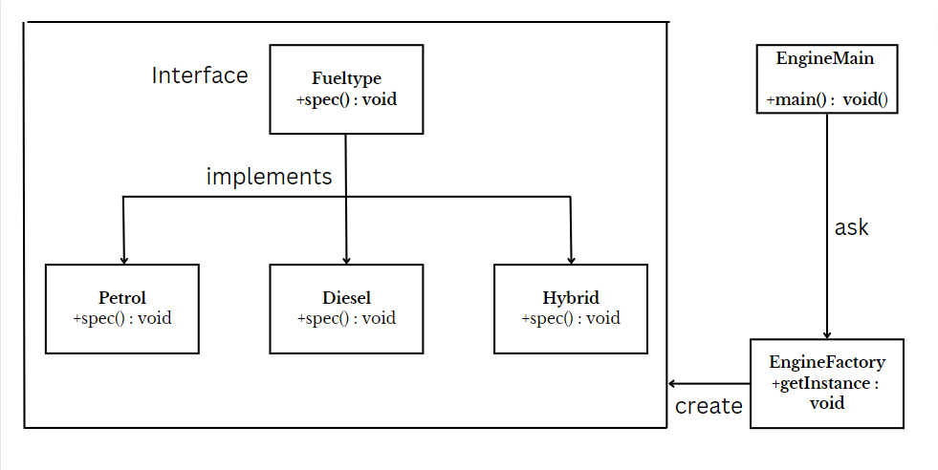

* **Code :**

package FactoryDesign2;

public interface FuelType

{

public void spec();

}

package FactoryDesign2;

public class Petrol implements FuelType

{

@ Override

public void spec()

{

System.out.println("Petrol Engine - SPress the gas & feel the power!!");

}

}

package FactoryDesign2;

public class Diesel implements FuelType

{

public void spec()

{

System.out.println("Diesel Engine - Want economy, this is for you");

}

}

package FactoryDesign2;

public class Hybrid implements FuelType

{

@ Override

public void spec()

{

System.out.println("Hybrid Engine - Are you a tech lover?");

}

}

package FactoryDesign2;

public class EngineFactory

{

public FuelType getInstance(String str)

{

if (str.equals("Grawl"))

return new Petrol();

else if (str.equals("Smoky"))

return new Diesel();

else

return new Hybrid();

}

}

package FactoryDesign2;

public class EngineMain

{

public static void main(String[] args)

{

EngineFactory ftf = new EngineFactory();

FuelType obj = ftf.getInstance("Grawl");

obj.spec();

}

}

* **Output :**

